**Installation of Codeblocks 17 in Microsoft window 10**

1. Run the Codeblocks 17 Setup file “Codeblocks17.12-setup .exe”. Click on the “Next” button.

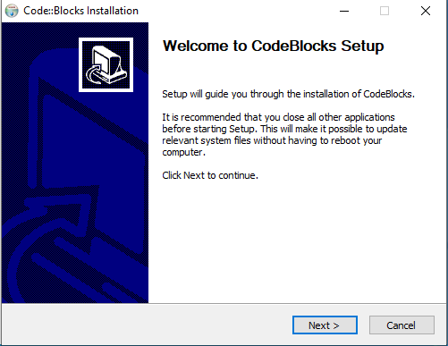

1. Accept the “License Agreement” and click “I Agree” button.

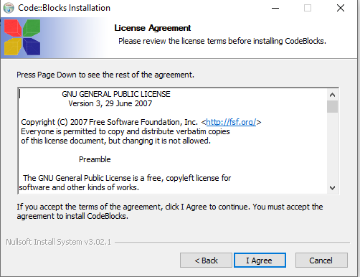

1. In the next window, Code Blocks will ask you to select components you want to install. Select Full Installation. Click on “Next” button.

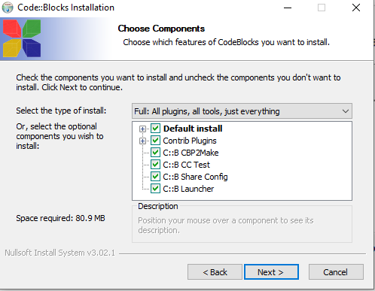

1. Select the Destination Folder (keep it default) and Click “Next” button.

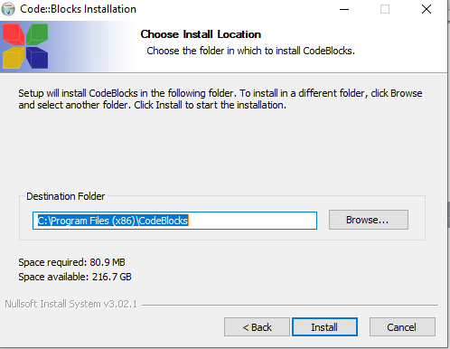

1. The installer will proceed to complete the installation.

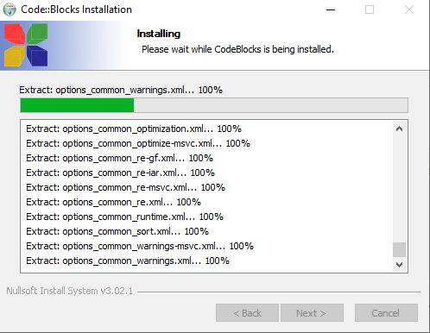

1. Ask the Question “Do you want to run code:: blocks now”. Click “Yes” button.

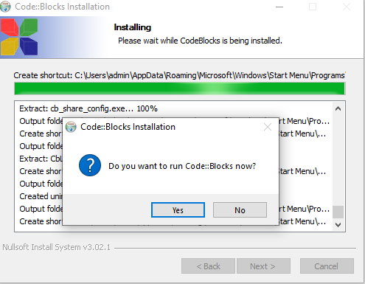

1. Installation has been completed. Click on the “Next” button.

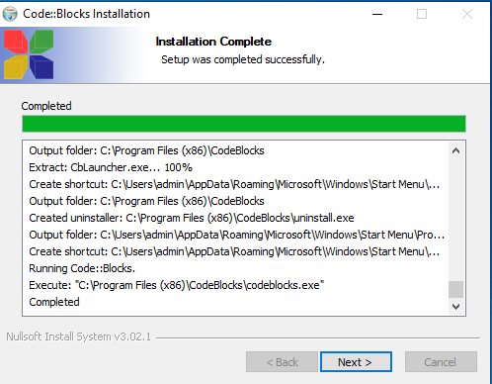

1. Click on the “Finish” button.

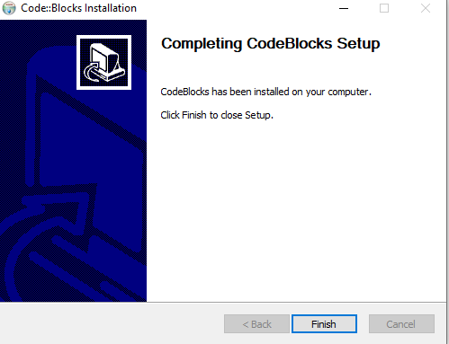

1. The preview of “Code Blocks” as shown.

